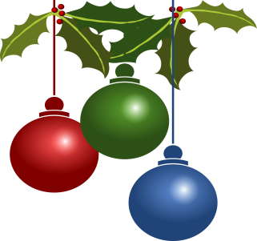

Bury Art Society

Christmas Newsletter
2017

That time of the year again, how time flies! Our academic year has once again got off to a flying start with Derek’s exciting programme looking at artists such as Hokusai, Heath Robinson, Aubrey Beardsley and Inuit art, as well as Life drawing sessions and demonstration/workshops with our own members Olga Lomas and Anne Fryers. To complete the Autumn term, at the time of writing, just the “Christmas Do” to come when the title of the annual competition will be announced followed by explanation and details next term.

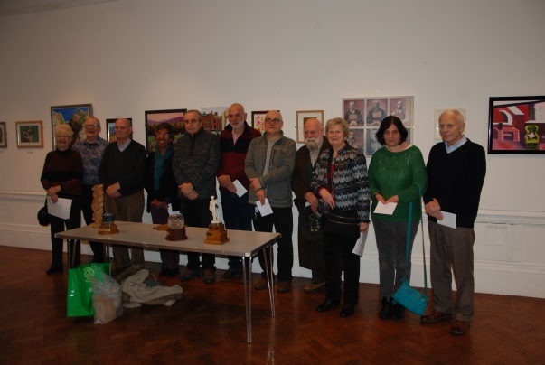
On Saturday 3rd December, Richard Burrows, the recently retired Curator of Bury Art Museum, opened the Annual Exhibition which this year is running in conjunction with a retrospective exhibition of the work of our President, David Swithenbank. The Millennium Prize was awarded to Phil Jones, The David Swithenbank award went to Judy Turner; Tommy Valentine Award to Phil Raynes; Mary Edyvean Award to Andrew Clark; Life Image Award to Dennis Markuss. Paintings by Malcolm Lucas and Irene Cotterell were Highly Commended and Judith Church, Louise Minor and Wright Platt had work Commended. The exhibition runs until Saturday, 4th February.

Following on from the successful trip to Lady Lever Gallery, Port Sunlight, Bernice Davenport and Pam Stone are looking into a number of venues for 2018, the first of which will be to Chester, details of which will be available in the New Year.

We have been delighted to welcome a number of new members since the beginning of this academic year but unfortunately one or two members have left for pastures new or because of other commitments are unable to attend.

At last the book cupboard has been replaced in the Studio and a large selection of books on all aspects of art are now available to everyone.

The date of the Society’s annual dinner will be next March – the venue will once again be Bella Italia in Bury – full details of price and menus will be circulated shortly.

In the last Newsletter I recorded the sad news of the passing of Mary Shaw. Mary requested that donations be made to Bury Art Society in lieu of flowers at her funeral. A sum of over £500 was recently received from Mary’s family and the Committee are now looking at ways to use this legacy in memory of Mary.

A very Merry Christmas and Good Wishes for a
Happy and Healthy New Year

Peggy Hargreaves, Secretary

